Standard(s):
8.G.6, 8.G.7 and 8.G.8
Questions | Answers
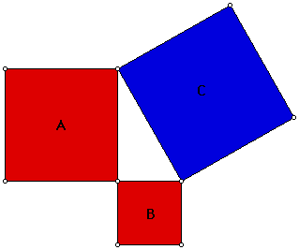  - If the triangle is right, describe the relationship between squares A, B, and C. | 1.
2. To get to football practice Brandon walks seven blocks south and then six blocks west. How much shorter would it be if he could walk directly to school? | 2.
3. Dehlia has several sticks, whose lengths are recorded below.  15 in, 5 in, 4 in, 9 in and 12 in.  She wants to use three of them to make a right triangle. Which three should she choose and why? | 3.
4. A right triangle has one leg with a length of 2.8 inches and another leg with a length of 11.3 inches. What is the approximate length of the hypotenuse of the triangle? | 4.
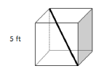  5. What is the approximate measurement of the diagonal of the cube if the cube’s length is 6 feet? | 5.

Standard(s):
NC.M1.A-CED.2 and NC.M1.A-REI.6
Questions | Answers
1. Oasis Fitness members pay a $20 membership fee and $3 for each class they take. Non-members pay $6 for each class at Oasis Fitness they take. Write and solve a system of equations to determine when the memberships would cost the same. | 1.
2. Tickets for a concert cost $35 each if you order them online, but you have to pay a service fee of $15 per order (unlimited tickets per order). The tickets are $49 the night of the concert at the door. Write and solve a system of equations that would help you determine which way you should buy 6 tickets. | 2.
3. A online streaming plan is $9 a month plus $2 per premium feature. A second plan costs $15 a month and $1 for each premium feature. Write, graph, and solve a system of equations that would help you determine the number of premium features that would make the online streaming plans cost the same amount. | 3.
4. Your team is planning a field trip for 130 people. The trip will use four drivers and two types of vehicles: buses and vans. A bus can seat 50 passengers and a van can seat 15. Write and solve a system of equations to find how many buses and vans will be needed. | 4.
5. Two angles are complementary. One angle is 10 degrees larger than the other. Find the measure of each angle. | 5.

Standard(s):
NC.M1.A-CED.3 and NC.M1.A-REI.6
Questions | Answers
1. One plane at 400 feet is ascending at a rate of 100 feet per minute, while another plane at 3200 feet is descending at a rate of 75 feet per minute. How long will it take the two planes to be at the same altitude? | 1.
2. I was planning to spend no more than $30 on meat for a cookout. I need to buy both hamburger and chicken. Hamburger costs $4.00/lb. and chicken costs $2.50/lb.. Graph and find three possible combinations of hamburger and chicken I can buy? | 2.
3. A website allows users to download individual songs or an entire album. All individual songs cost the same to download, and all albums cost the same to download. Ryan pays $14.94 to download 5 individual songs and 1 album. Seth pays $22.95 to download 3 individual songs and 2 albums. How much does the website charge to download a song? How about an entire album? | 3.
4. Taxis in Raleigh charge $2.25 to pick up and add $2.80 per mile. In Chicago, taxis charge $4.50 and add $1.75 for each quarter mile. How many miles and for what price could you take a taxi in both cities for the same price? | 4.
5. Friends often pick up lunch for each other. When it was Mike’s turn to make the food run, he bought 5 sandwiches and 3 bags of chips. He spent $29.50. When Lisa went, she got 4 sandwiches and 4 bags of chips for $26. How much does a sandwich cost? How about a bag of chips? | 5.

Standard(s):
NC.M1.A-REI.5
Questions | Answers
1. In order to solve the system of equations below using the elimination method, what would be the best first step and why?  $$\left\{\begin{aligned}x+y=7 \\ \\ x-y=8\end{aligned}\right\}$$ | 1.
2. In order to solve the system of equations below using the elimination method, what would be the best first step and why?  $$\left\{\begin{aligned}4x-2y= -7 \\ \\ x+5y=6\end{aligned}\right\}$$ | 2.
3. For the system$\left\{\begin{aligned}4x-2y= 11 \\ \\ 3x+y=7\end{aligned}\right\}$, which variable should you eliminate first and why? | 3.
4. In order to solve the system of equations below using the elimination method, what would be the best first step? $\left\{\begin{aligned}10x-3y= -8 \\ \\ 2y=5x+4\end{aligned}\right\}$ | 4.
5. Iyanna decided to solve the system using elimination by multiplying the first equation by 3. Is this the best first step Ingrid could take?$$\left\{\begin{aligned}x-2y=3 \\ \\ 3x+5y=12\end{aligned}\right\}$$ | 5.

Standard(s):
NC.M1.A-REI.12
Questions | Answers
1.Highlight on the graph the solution set of the system of inequalities shown on the graph. Write a scenario that could be modeled by the solution set.  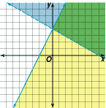 | 1.
2. Billy is a student and he can work for at most 20 hours a week. He needs to earn at least $375 to cover his weekly expenses. His car parking job pays $10.50 an hour and his pizza delivery job pays $12.75 an hour. Write and graph a system of inequalities for the given situation. | 2.
3. Jack is packing containers into boxes for shipping. Each box can hold either 16 small containers or 4 large containers. He needs to pack at least 20 boxes and at least 450 containers. Write and graph a system of inequalities for the given situation. | 3.
4. The HGMS Garden Club is buying plants and soil for the garden. The soil costs $4.50 per bag and the plants cost $7.50 each. They want to buy at least 20 plants and can spend no more than $250. Write and graph a system of inequalities for the given situation. | 4.
5. Maryanna wants to bake at most 30 dozen cookies for a bake sale. She wants to make sugar cookies that sells for $2.95 per dozen and peanut butter chocolate chip cookies that sells for $4.50 per dozen. She also wants to make at least $80 in sales. Write and graph a system of inequalities for the given situation. | 5.

Standard(s):
NC.M1.G-GPE.4
Questions | Answers
1. A triangle has vertices A (1,1), B (-2,-3), and C(5,-2). Find the perimeter of the triangle. Round to the nearest hundredth. | 1.
2. Triangle ABC has vertices located at (-5, 1), (-5, 9) and (1,1). What type of triangle is ABC? | 2.
3. A quadrilateral has vertices (1,2), (1, 6), and (9,6). Find the fourth vertex. Verify it is a rectangle, providing evidence. | 3.
4. What shape most precisely describes the quadrilateral with vertices at  (-10, -7), (-6, 1), (-4, 1) and (-1, -7)? | 4.
5. Triangle ABC has a right triangle at C. How could you prove that this is a right triangle?  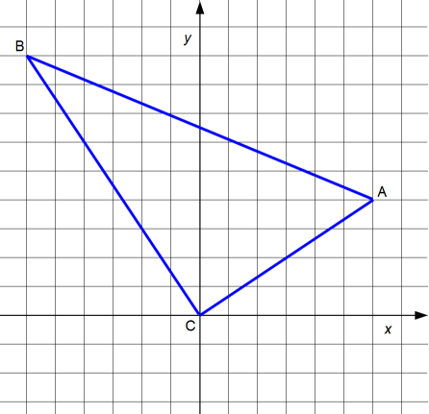 | 5.

Standard(s):
NC.M1.G-GPE.5
Questions | Answers
1. Write an equation in slope-intercept form for the lines that passes through point (7, -8) and is parallel to y = x - 5. | 1.
2. Write an equation in slope-intercept form for the lines that passes through point (4, 8) and is parallel to  5x – y = 7. | 2.
3. Write an equation in slope-intercept form for the lines that passes through point (-6, 3) and is perpendicular to  Y = (1/3)x - 4. | 3.
4. Write an equation in slope-intercept form for the lines perpendicular to the graph of the equation y = (3/4)x – 9 and passes through the x-intercept of that line. | 4.
5. If the line through (4, 4) and (5, d) is parallel to the graph of y = 6x + 5, what is the value of d? | 5.

Standard(s):
NC.M1.G-GPE.6
Questions | Answers
1. What are the coordinates of the midpoint of the line segment with endpoints at (7, -4) and (8, -8)? | 1.
2. Circle H has a diameter BF. The center of Circle H has coordinates (-7, -9) and Point B has coordinates (5, 7). What are the coordinates of Point F? | 2.
3. The vertices of a parallelogram HIJK are H(-8, -5), I(-6, 5), J(4, 5) and K(2, -5). The diagonals HJ and IK intercept at their midpoints, point P. Find the coordinates of P. | 3.
4. A map is drawn on a coordinate grid. The school is located midway between Star’s house at (-4, 8) and Moon’s house at (10, 12). Where is the school located on the map? | 4.
5. A circle has a diameter that extend from (-5, -9) to (8, -5). What are the coordinates of the center of the circle? | 5.

Standard(s):
8.EE.8
Questions | Answers
1. Sue and Hannah both leave for the post office at the same time. Sue walks from her house to the post office. The equation $d=-2t+4$ represents the distance d, in miles Sue walks in t hours. Hannah drives her car to the post office. The equation $d=10t$, represents her d is distance in miles for each hour, t.  After how many minutes will Sue and Hannah meet? | 1.
2. Admission to a local amusement park cost $42 for children ages 3-12 and $60 for adults ages 12 and up. Jake and his boy scout troop bought a total of 23 children tickets. If the group spent a total of $1,206 dollars on tickets, how many adult tickets were purchased? | 2.
- Solve the following system of equations:  $$5x+ y=7 \\ 15x+3y=21$$ | 3.
4. Find the solution to the system, then find the product of x and y.  $$y+3=x \\ y=\frac{1}{7}x+3$$ | 4.
5.Solve the system of equations.  $$-4x+6y=50 \\ -2x+6y=58$$ | 5.

