Geologic time- Earth’s history is divided into time units that make up the _____________________________.
Time units on the scale are based on__________________________________________________________
________________________________________________________________________________________
Example: ____________________, a type of index fossils that live during specific periods of time.
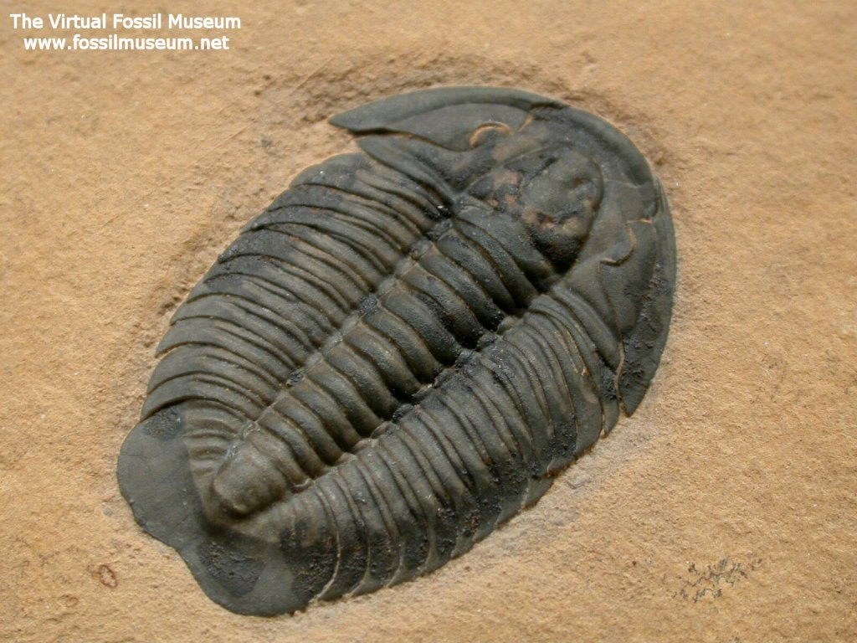
When did they appear?
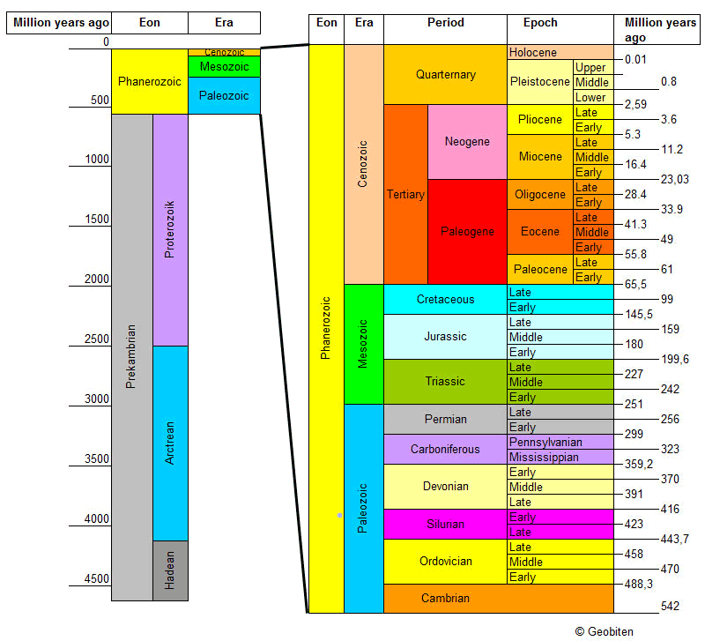
When did they go extinct?

Geologic time is divided into _____major subdivisions:
Eons - __________________________________________________________________________________
Eras - __________________________________________________________________________________
Periods - ________________________________________________________________________________
Epochs - ________________________________________________________________________________

The fossil record indicates that species have _____________ and ____________ over time.
Charles Darwin is responsible for proposing _________________________________________________.
The ___________________________ explains how continents moving throughout time have influenced the environments of past organisms.

Mass Extinction - periods in Earth's history when abnormally _____________________________________
_______________________________ simultaneously or within a limited time frame.
  - The _________________________________ is marked by a Mass Extinction.
  - The most severe occurred at the end of the ___________________ Era when 96% of all species perished.
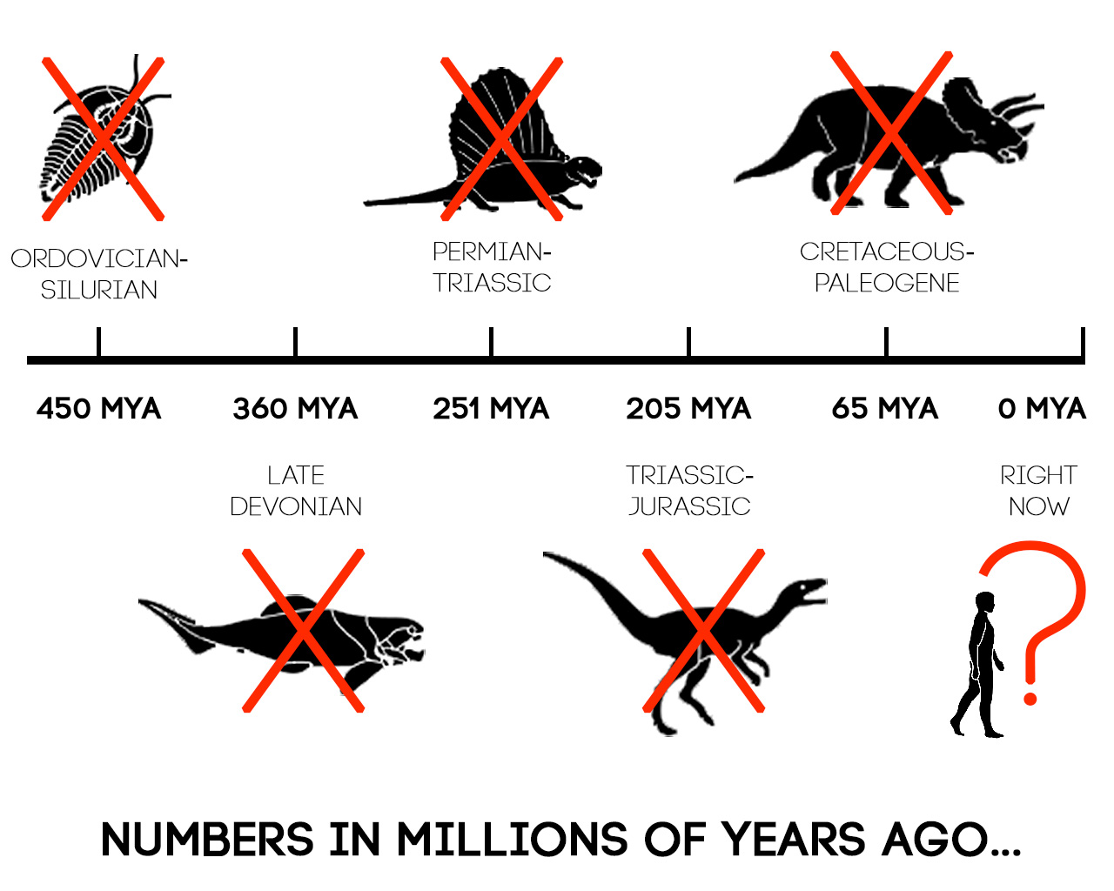

Major Events of the Geologic Time Scale
Precambrian Time
4 billion - 540 million years ago

- Very ______ fossils remain from this time.
  - Many Precambrian rocks were deeply buried, causing the fossils in them to be changed by __________________________________________.
- Most Precambrian organisms lacked ___________________.
  - Cyanobacteria are _______________________, one of the earliest life forms to appear.
Paleozoic Era
540 - 245 million years ago

  - ___________________________ with shells evolved in the warm, shallow seas.
  - ___________________________ evolved to survive in water and on land.
  - ________________ evolved from amphibians to survive farther from water.
  - ___________________________ caused mountains to form as ____________ comes together.
  - Most marine species became extinct at the end of the Paleozoic Era.
  - Mass Extinction = __________________________________________________________

Mesozoic Era
245 - 65 million years ago

  - _______________ separated into continents and the climate became ________.
  - ____________________ dominate.
  - ___________ appear during the Jurassic Period.
  - Small, mouse-like ____________________appear in the Triassic Period.
  - ________________________ appeared during the Cretaceous period.
  - Due to extreme climate change from volcanic activity and meteors, the _______________die off.
  - Mass Extinction = ___________________________

The Cenozoic Era
65 million years ago - present day

  - Many __________________________ ranges formed.
  - Colder climates; 3 Major ____________________ occur during this Era.
  - ______________________ continued to evolve.
  - Many species became ___________________ as the continents continued to separate.
  - Fossils of homo sapiens (_______________) show their appearance about 400,000 years ago.

