Evidence of Evolution Notes
The Theory of Evolution Review:
- Organisms develop _________________________ to their environment in order to survive. The better suited they are to the environment, the longer they will survive (“_________________________________________”). Those adaptations or traits are __________________________ passed down to their _____________________.
Genetic Variation - ____________________________________________________________________________________________________________________________________________________________________________________________________
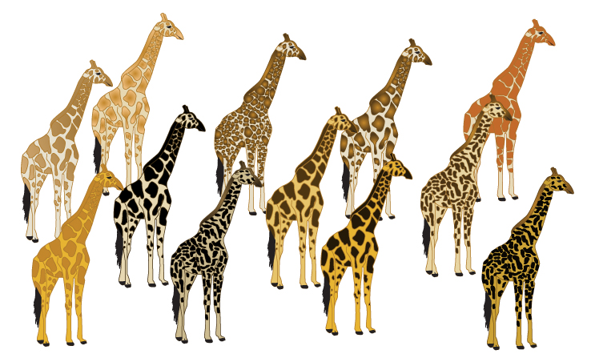
Why do these Giraffes have different colors and patterns?

How Do We Know Evolution Has Occurred?
- Supported by ___________________ evidence
Fossils - ___________________________________________________________________________________________
- Provide a ________________________________________________ on earth
- Comparison of organisms living ____________ and organisms in the __________________________ enable the reconstruction of evolutionary history.
Evidence of Evolution:
Embryology - Developing embryos of different animals have _________________________________________. These similarities hint at the ________________ inherited by _________________________________________.
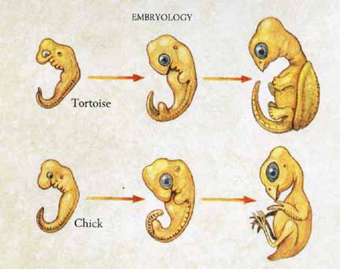
Look at the embryos from a Tortoise and a Chicken. As adults they have very different traits and appearances. But as embryos they look very similar. How can this support the Theory of Evolution?
Comparative Anatomy - Analysis of ______________________________________ of two or more species that provides insight into the genetic/biological __________________________ and ____________________________ across species.

Homologous Structures - Similar ___________________________________________ or systems with the same __________________________________________________________.
  - May or may not have _________________________________________.
  - The structure ____________________________________________ in animals to better suit their ___________________________________.
Example:

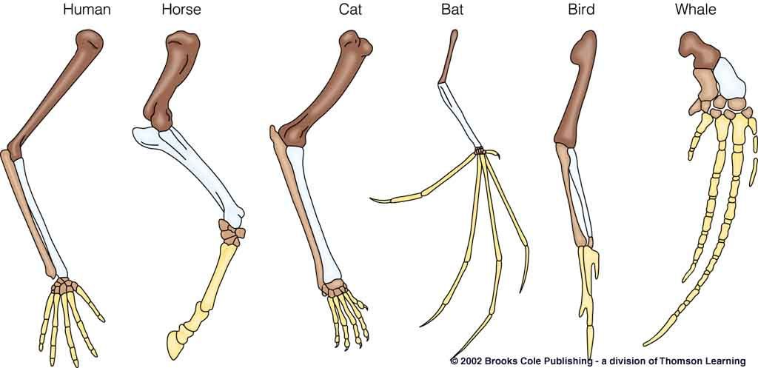

Vestigial Structures
  - Have _______________________________________________________________ (or lesser function)
  - Suggest the ____________________________________________________________ through evolution
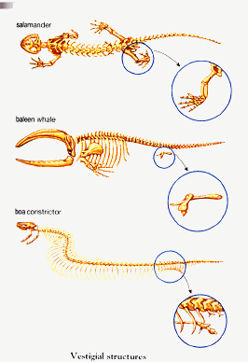
Example: The hip bones (that connect to legs) appear in organisms of many species, despite the function of these bones. The salamander still uses these bones today, but does the whale and snake?
Why would the whale and snake still have these bones but not use them?

