Standard(s):
8.F.1
Questions | Answers
- Does the following relation define a Function?
$$x^{2}+y^{2}=49$$
2. Does the following table represent a function?

x | y
2 | -4
4 | 8
5 | 4
4 | -2
0 | 1

3. Does the following graph represent a function?

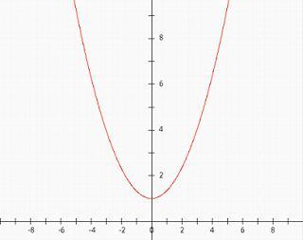
4. Is the following relation a function?  (-1, 2) (3, 2) (5, 2) (0, 2) (4,2) | 4.
5. Does the following graph represent a function?
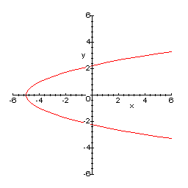

Standard(s):
8.F.2
Questions | Answers
1. Which function below would have a negative rate of change?
Function 1:
Josiah was gifted $75 for his birthday. Each week he stops at the local candy store and spends $1.25. Let y represent the amount of money has after, x, number of weeks.
Function 2:
Ian currently has 16 baseball cards. He buys two new cards each month. Let y represent the number of cards after, x, number of months.
- Which function has the greater rate of change?
Function 1:

x | y
-3 | 5
0 | 4
3 | 3
6 | 2

Function 2:
$$y=-\frac{1}{2}x+5$$

- The functions below represent the amount of money Jenny and Hollie earn mowing lawns. Both charge a fee for transporting their equipment plus a certain amount per acre mowed. Let y represent the amount earned, for each acre of land, x.

Jenny:
y = 5x + 10
Holly
# of acres | Earnings
0 | 15
5 | 35
10 | 55
15 | 75
20 | 95

Who charges more to mow an acre of land? Who has the larger transportation charge?

$
4. Compare the cost of apples at the following stores:
- Store A sells 5lb. of apples for $3.85.
- Store B sells apples at the following rate:
Number of pounds | Cost
1 | .80
2 | 1.60
3 | 2.40
4 | 3.20

If Lukes buys three pounds of apples, which store should he go to for the cheapest price? How much will he save at this store?
5. A candle burns at a rate of
$y=-1.25x+8$, where y is the height of the candle after burning x hours.
Write a function rule for a candle with the same starting height as the candle above, but that burns at a faster rate.

Standard(s):
8.F.5
Questions | Answers
- Use the coordinate grid below to sketch a graph of a continuous function that
- is increasing and nonlinear from x = –3 to x = 0
- is linear and has a negative slope from x = 0 to x = 3,
- and is decreasing and nonlinear from x = 3 to x = 9.
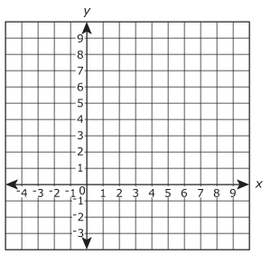

- Use the graph below to describe Devin’s trip to school.
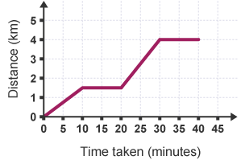
- Is the function below linear or non-linear? Name the x-interval of the function that is decreasing.
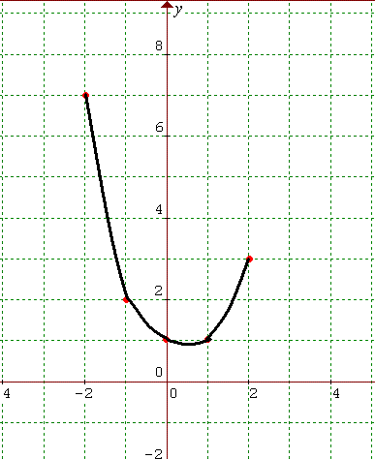
- Draw a speed-time graph that represents the following situation. Jordan leaves for work in his car. He starts by accelerating until he reaches 5 miles over the speed limit. He decreases his speed to the speed limit and then drives at a constant speed.
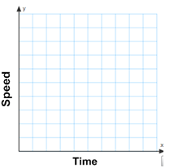

5.Use the coordinate grid below to sket;ch a graph of a continuous function that:
- is increasing and linear from
x = –4 to x = -2
- is linear and has a negative slope from x = -2to x = 2
- is increasing and nonlinear from x = 2 to x = 5.
- and is increasing and linear from
x = 5 to x = 10.

